**- Different Heart Disease Information Which Leads To Cardiac Arrest-**

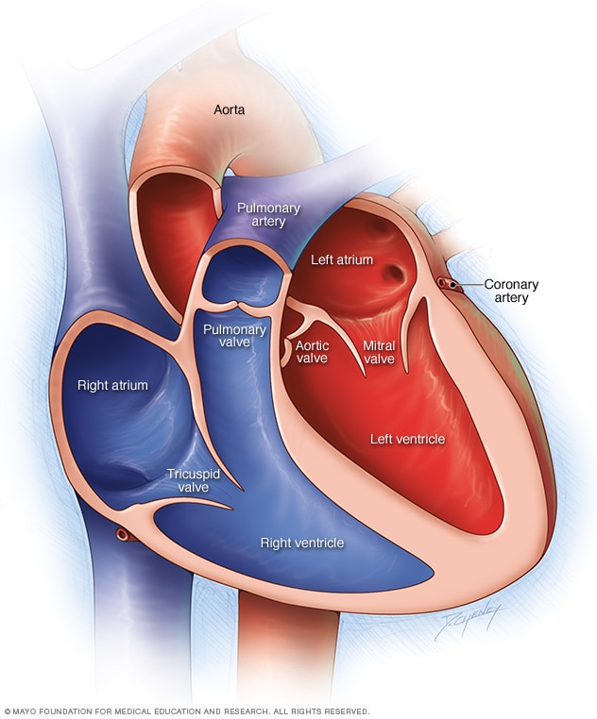

1. **Normal :** Normal Parameters
2. **Ischemic Changes (Coronary Artery):**

The usual cause is the buildup of plaque. This causes coronary arteries to narrow, limiting blood flow to the heart. This can ultimately **lead to heart attack**. Ischemia often causes chest pain or discomfort known as angina pectoris. Coronary artery disease can range from no symptoms, **to chest pain, to a heart attack.** Treatments include lifestyle changes, medication, angioplasty and surgery.

**Medicines :**

Cholesterol-modifying medications,

Aspirin,

Beta blockers,

Calcium channel blockers,

Ranolazine,

Nitroglycerin,

Angiotensin-converting enzyme (ACE) inhibitors

Angiotensin II receptor blockers (ARBs).

1. **Old Anterior Myocardial Infarction :**

An anterior wall myocardial infarction - also known as anterior wall MI, or AWMI, or anterior ST segment elevation MI, or anterior STEMI - occurs when anterior myocardial tissue usually supplied by the left anterior descending coronary artery suffers injury due to **lack of blood supply**. When an AWMI extends to the septal and lateral regions as well, the culprit lesion is usually more proximal in the LAD or even in the left main coronary artery. This large anterior myocardial infarction is termed an extensive anterior.

**Medicines :**

Cholesterol-modifying medications,

Aspirin,

Beta blockers,

Calcium channel blockers,

Ranolazine,

Nitroglycerin,

Angiotensin-converting enzyme (ACE) inhibitors

Angiotensin II receptor blockers (ARBs).

1. **Old Inferior Myocardial Infarction :**

An inferior infarct on ECG (inferior myocardial infarction or inferior STEMI) occurs when inferior myocardial tissue supplied by the right coronary artery (RCA), is injured due to thrombosis of that vessel. When an inferior myocardial infarction extends to posterior regions as well, an associated posterior wall myocardial **infarction may occur**.

**Medicines :**

Cholesterol-modifying medications,

Aspirin,

Beta blockers,

Calcium channel blockers,

Ranolazine,

Nitroglycerin,

Angiotensin-converting enzyme (ACE) inhibitors

Angiotensin II receptor blockers (ARBs).

1. **Sinus Tachycardia :**

Sinus tachycardia refers to a faster-than-usual heart rhythm. Your heart has a natural pacemaker called the sinus node, which generates electrical impulses that move through your heart muscle and cause it to contract, or beat. When these electrical impulses are transmitted normally, it’s referred to as normal sinus rhythm. Normal sinus rhythm typically results in a heart rate of 60 to 100 beats per minute.

Sometimes, these electrical impulses are sent out faster than normal, causing sinus tachycardia, which often results in a heart rate of over 100 beats per minute. If left untreated, tachycardia can disrupt normal heart function and lead to serious complications, including: **Heart failure, Stroke, Sudden cardiac arrest or death.** Treatments, such as drugs, medical procedures or surgery, may help control a rapid heartbeat or manage other conditions contributing to tachycardia.

**Medicines :**

Cholesterol-modifying medications,

Aspirin,

Beta blockers,

Calcium channel blockers,

Ranolazine,

Nitroglycerin,

Angiotensin-converting enzyme (ACE) inhibitors

Angiotensin II receptor blockers (ARBs).

1. **Sinus Bradycardia :**

Sinus bradycardia is a type of slow heartbeat. A special group of cells begin the signal to start your heartbeat. These cells are in the sinoatrial (SA) node. Normally, the SA node fires the signal at about 60 to 100 times per minute at rest. In sinus bradycardia, the node fires less than 60 times per minute. Bradycardia means a slow heartbeat. In sinus bradycardia, the heartbeat is starting in the normal part of the electrical system, the SA node. When bradycardia is more severe, you may experience shortness of breath, chest pain, and fainting. If severe bradycardia goes untreated, it could **lead to cardiac arrest**, meaning the **heart stops beating**, and that **can lead to death**.

**Medicines :**

Cholesterol-modifying medications,

Aspirin,

Beta blockers,

Calcium channel blockers,

Ranolazine,

Nitroglycerin,

Angiotensin-converting enzyme (ACE) inhibitors

Angiotensin II receptor blockers (ARBs).

1. **Premature ventricular contractions (PVCs) :**

Premature ventricular contractions (PVCs) are extra heartbeats that begin in one of your heart's two lower pumping chambers (ventricles). These extra beats disrupt your regular heart rhythm, sometimes causing you to feel a fluttering or a skipped beat in your chest. If you have frequent premature ventricular contractions or underlying heart disease, you might need treatment. Having frequent PVCs or certain patterns of them might increase your risk of developing **heart rhythm problems** (arrhythmias) or **weakening of the heart** **muscle** (cardiomyopathy).

**Medicines :**

Cholesterol-modifying medications,

Aspirin,

Beta blockers,

Calcium channel blockers,

Ranolazine,

Nitroglycerin,

Angiotensin-converting enzyme (ACE) inhibitors

Angiotensin II receptor blockers (ARBs).

1. **Supraventricular Premature Contractions :**

Supraventricular premature beats represent premature activation of the atria from a site other than the sinus node and can originate from the atria or the atrioventricular node (called junctional **premature beats**), though the vast majority are atrial in origin. Atrial premature beats (APBs), also referred to as atrial premature complexes, premature atrial beats, are triggered from the atrial myocardium in a variety of situations and occur in a broad spectrum of the population. This includes patients without structural heart disease and those with any form of cardiac disease, independent of severity.

**Medicines :**

Cholesterol-modifying medications,

Aspirin,

Beta blockers,

Calcium channel blockers,

Ranolazine,

Nitroglycerin,

Angiotensin-converting enzyme (ACE) inhibitors

Angiotensin II receptor blockers (ARBs).

1. **Left bundle branch block :**

Left bundle branch block (LBBB) is a cardiac conduction abnormality seen on the electrocardiogram (ECG). In this condition, activation of the left ventricle of the heart is delayed, which causes the left ventricle to contract later than the right ventricle. People with a left side bundle branch block have a higher risk of complications than those with a right side block. Possible complications include: **insufficient contraction, cardiac arrest and circulatory failure, sudden cardiac death,** which can be fatal within one hour of symptoms starting.

**Medicines :**

Cholesterol-modifying medications,

Aspirin,

Beta blockers,

Calcium channel blockers,

Ranolazine,

Nitroglycerin,

Angiotensin-converting enzyme (ACE) inhibitors

Angiotensin II receptor blockers (ARBs).

1. **Right bundle branch block :**

A right bundle branch block (RBBB) is a heart block in the right bundle branch of the electrical conduction system. During a right bundle branch block, the right ventricle is not directly activated by impulses travelling through the right bundle branch. The main complication of **bundle branch block, right**, is to progress to a complete block of the electric conduction from the upper chambers of the heart to the lower. This can **slow your heart rate**, which can cause fainting and lead to **serious** **complications** and **abnormal heart rhythms.**

**Medicines :**

Cholesterol-modifying medications,

Aspirin,

Beta blockers,

Calcium channel blockers,

Ranolazine,

Nitroglycerin,

Angiotensin-converting enzyme (ACE) inhibitors

Angiotensin II receptor blockers (ARBs).

1. **left ventricular hypertrophy :**

Left ventricular hypertrophy is enlargement (hypertrophy) of the muscle tissue that makes up the wall of your heart's main pumping chamber (left ventricle). Left ventricular hypertrophy develops in response to some factor, such as high blood pressure, that requires the **left ventricle to work harder**. It can occur when some factor **makes your heart work harder** than normal to pump blood to your body.

**Medicines :**

Cholesterol-modifying medications,

Aspirin,

Beta blockers,

Calcium channel blockers,

Ranolazine,

Nitroglycerin,

Angiotensin-converting enzyme (ACE) inhibitors

Angiotensin II receptor blockers (ARBs).

1. **Atrial fibrillation or flutter:**

Atrial fibrillation is an irregular and often rapid heart rate that can increase your risk of stroke, heart failure and other heart-related complications. During atrial fibrillation, the heart's two upper chambers (the atria) beat chaotically and irregularly - out of coordination with the two lower chambers (the ventricles) of the heart. Atrial fibrillation symptoms often include **heart palpitations, shortness of breath and weakness**. If a blood clot forms, it could dislodge from your heart and travel to your brain. There it might block blood flow, **causing a stroke**.

**Medicines :**

Cholesterol-modifying medications,

Aspirin,

Beta blockers,

Calcium channel blockers,

Ranolazine,

Nitroglycerin,

Angiotensin-converting enzyme (ACE) inhibitors

Angiotensin II receptor blockers (ARBs).